US Military Bases

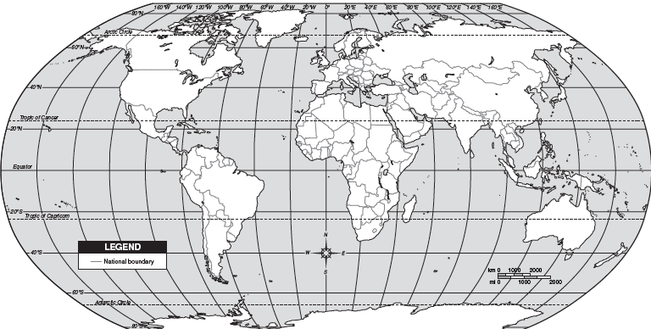

Label & Color all the countries that the United States has military bases located in. You may use your device or the list on the board.