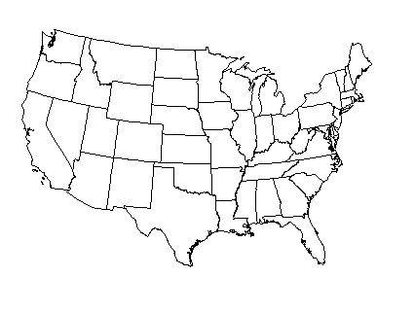
REPUBLICAN VS. DEMOCRATS

