UNDERSTANDING ISIS/ISIL

1) What does I.S.I.S. stand for?

2) What does I.S.I.L. stand for?

3) What do they want?

4) What is a caliphate?

Sunni = elected
Shiite = descendent of Muhammad

The caliphate was abolished in 1924 shortly after the Ottoman Empire was defeated (1922) and became Turkey. During the end of the Ottoman Empire the Ottomans committed the “Armenian Genocide” killing 1.5 million Armenians during WWI.

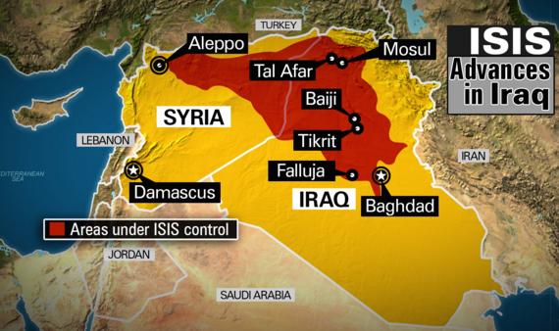
TODAY’S ISIS CALIPHATE

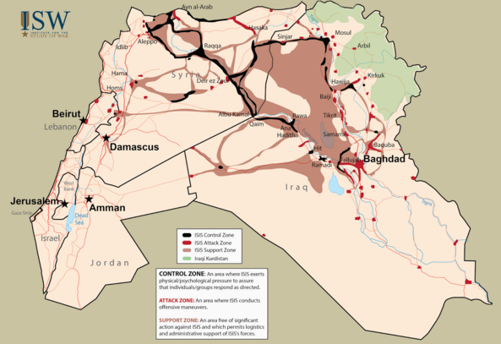

What are we doing about it?

Video clip: http://www.cnn.com/2014/10/06/world/meast/isis-coalition-nations/

Why is it so difficult?

Is it only the United States?

What do Muslim countries like Saudi Arabia, Qatar, Egypt, and UAE think about ISIS?

Could we have intervened earlier to prevent the ugliness of the situation?

Why is this more difficult than a traditional war?

Will this ever end? Ideology….

Opinion: Should we accept refugees from the Middle East?

Watch Video: http://geographyeducation.org/articles/teaching-about-syrian-refugees/

