Name_________________________

Domestic Tranquility Photo

What does this photo show about domestic tranquility in Afghanistan? (Be sure to look at the caption) Please answer using the following format.

When it comes to domestic tranquility, this photo suggests:

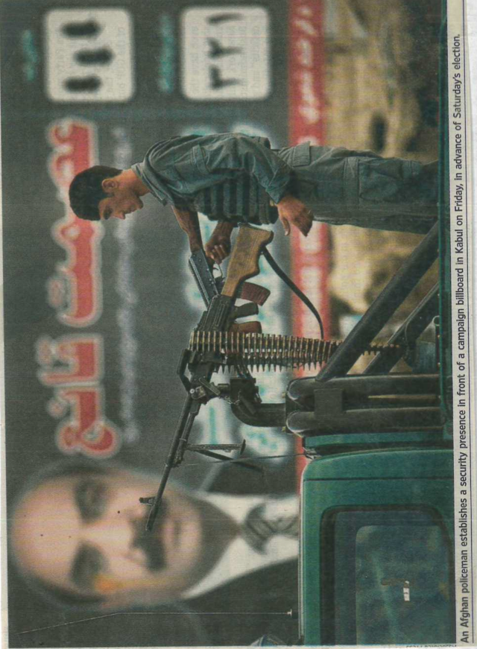
It suggests this because:

